Arrange a Wreath

Stamp Sets
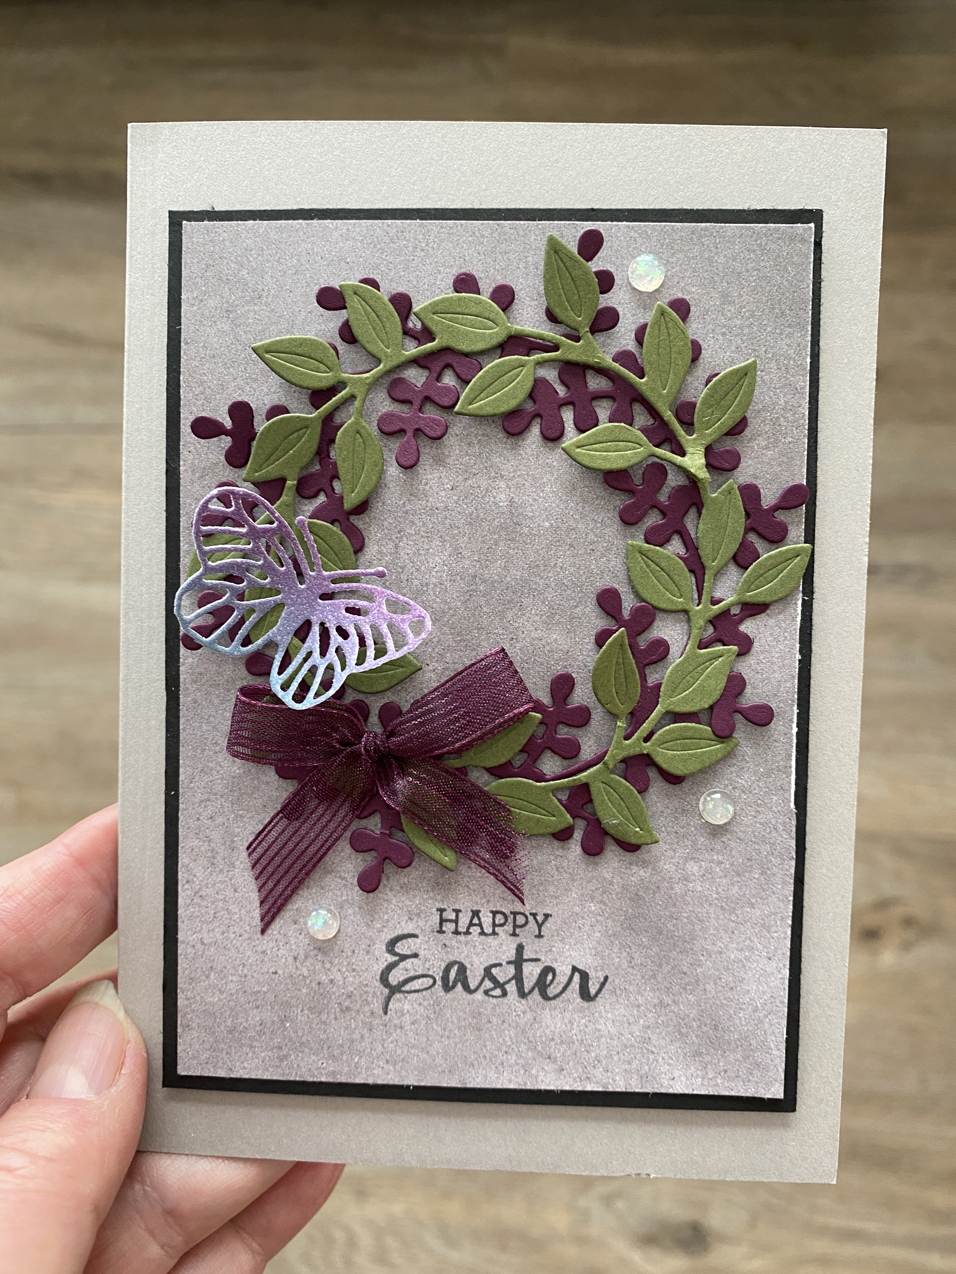
- Arrange A Wreath Bundle (154109)

Ink, Markers, & Other Colouring Options
- Tuxedo Black Memento Ink Pad (132708)

Cardstock, Designer Series Paper, etc.
- Smoky Slate Card Stock (131202)
- Blackberry Bliss Card Stock (133675)
- Mossy Meadow Card Stock (133676)
- In Good Taste Designer Series Paper (152494)
- Rainbow Glimmer Paper (153056)

Accessories
- Brilliant Wings Dies (155523)
- Blackberry Bliss 3/8” Striped Ribbon (154569)
- Stampin’ Seal (152813); Mini Glue Dots (103683) & Stampin’
Dimensionals (104430); Opal Rounds (154289)
All images © 1990-2021 Stampin’ Up!®

Measurements:
- Smoky Slate Card Stock: 8-1/2” x 5-1/2”, scored at 4-1/4 along the long side
- Basic Black Card Stock: 3-5/8” x 5”
- Blackberry Bliss Card Stock: 4” square
- Mossy Meadow Card Stock: 4” square
- In Good Taste DSP: 1/2” x 4-7/8”
- Rainbow Glimmer DSP: Scrap for 3 butterflies
- Blackberry Bliss 3/8” Ribbon: 8”

Instructions:
- Using the rounded leaf wreath die, cut a wreath shape out of Blackberry Bliss card stock. Using the oval leaf wreath die, cut a wreath shape out of Mossy Meadow card stock.
- Add several Mini Glue Dots to the back of the Blackberry wreath in inconspicuous places and adhere to grey slate pattern of In Good Taste DSP (see picture for placement).
- Add several Mini Glue Dots to the back of the Moss Meadow wreath in inconspicuous places and adhere overtop of the Blackberry Bliss wreath.
- Place a medium to small sized butterfly die on the scrap of Rainbow Glimmer paper, choosing a placement where the colours are gradient between Blackberry Bliss and Bermuda Bay. Add the 2 tiny butterflies to the same scrap of DSP and run through the Cut & Emboss Machine.
- Tie a small bow with the Blackberry Bliss 3/8” Striped Ribbon and trim tails as needed. Using 2 or more Mini Glue Dots, adhere the bow to the left lower area of the wreath.
- Using 2 Mini Glue Dots, add the larger of the die cut 3 butterflies just above the ribbon bow.
- Using Tuxedo Black Memento Ink, stamp the greeting of your choice below the wreath.
- Add 3 Opal Rounds to the card front.
- Add the 2 remaining tiny butterflies to the inside of the card and add your personalized greeting.
- Add stamped images or additional DSP to the outside of your envelope. Enjoy sending your card to someone special.

