Butterfly Collection Birthday

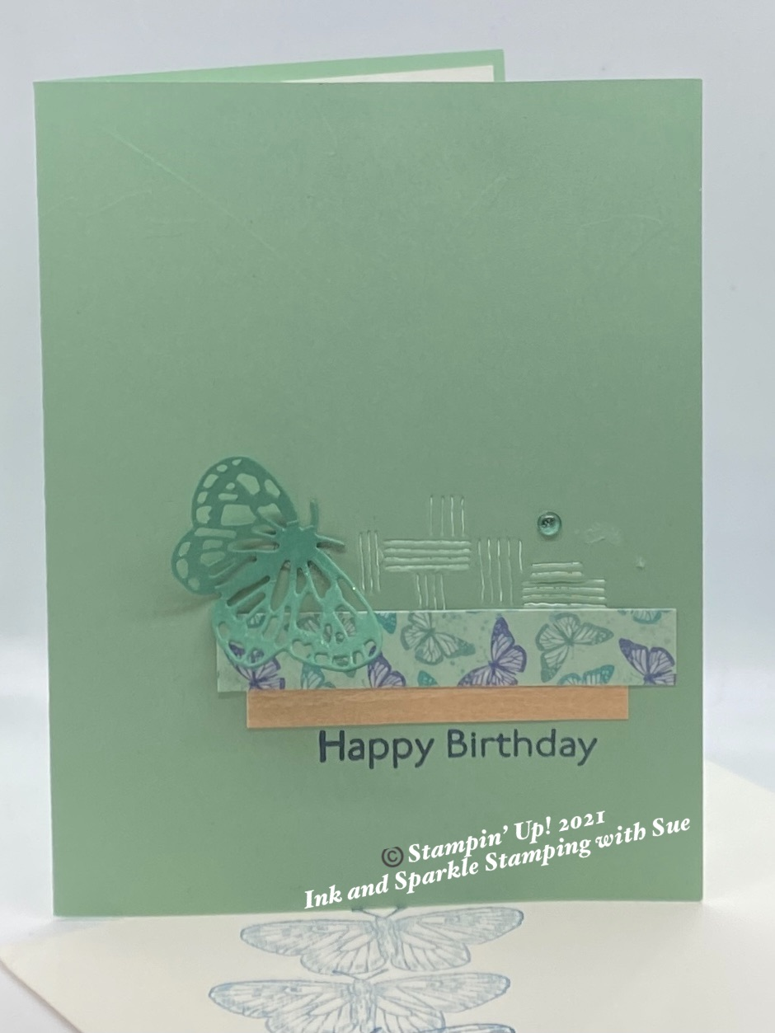
Stamp Sets
- Butterfly Brilliance Collection (159408) which includes the
stamp Set (155092)

Ink, Markers, & Other Colouring Options
- Misty Moonlight Ink Pad (153118)

Cardstock, Designer Series Paper, etc.
- Mint Macaron Card Stock (139338)
- Just Jade Card Stock (153079)
- Basic White Thick Cardstock (159229)
- Butterfly Bijou 6x6 Designer Series Paper included in the
Collection (DSP) (156824)
- Natural Touch Specialty Paper included in the Collection
(156825)

Accessories
- Stampin’ Seal (152813); Mini Glue Dots (103683)
- 2020-2022 In-Colour Enamel Dots (152480)

All images © 1990-2021 Stampin’ Up!®

Measurements:
- Mint Macaron Card Stock: 8-1/2” x 5-1/2”, scored at 4-1/4 along the long side
- Just Jade Card Stock: scrap approximately 2” x 1-1/4”
- Butterfly Bijou DSP: 1/2” x 3” plus 6” x 2-1/2” for the envelope flap (the Just
Jade/Misty Moonlight mini butterfly pattern)
- Natural Touch DSP: 5 1/2” x 3/4”

Instructions:
- Choose the lined die from the Brilliant Wings dies and place on the card from approximately 1/3 of the way from the bottom and slightly towards the right edge of the card front. Run this through the Cut & Emboss machine. Remove the die from the card base and go to step #2.
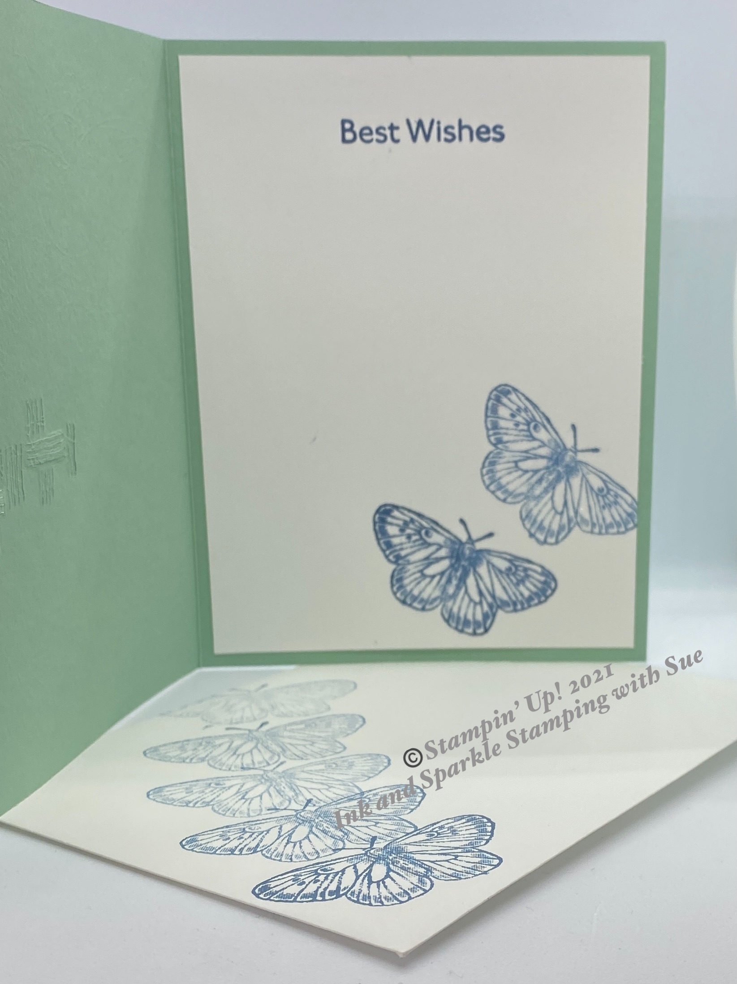
- Adhere the Natural Touch DSP layer under the Butterfly Bijou 1/2” x 3” piece and then adhere under the lined die cut, adhering over the bottom portion of the die cut.
- Using Misty Moonlight ink, stamp the “Happy Birthday” greeting on the card front, under the DSP layers.
- Choose one of the smaller butterfly dies and cut the image out of the Just Jade scrap. Roll a Mini Glue Dot and add to the back of the butterfly body; add another full circular Mini Glue under the wider part of the butterfly body and adhere to the left and above the DSP layers (see picture).
- Add a Just Jade coloured Enamel Dot above and to the right of the DSP layer.
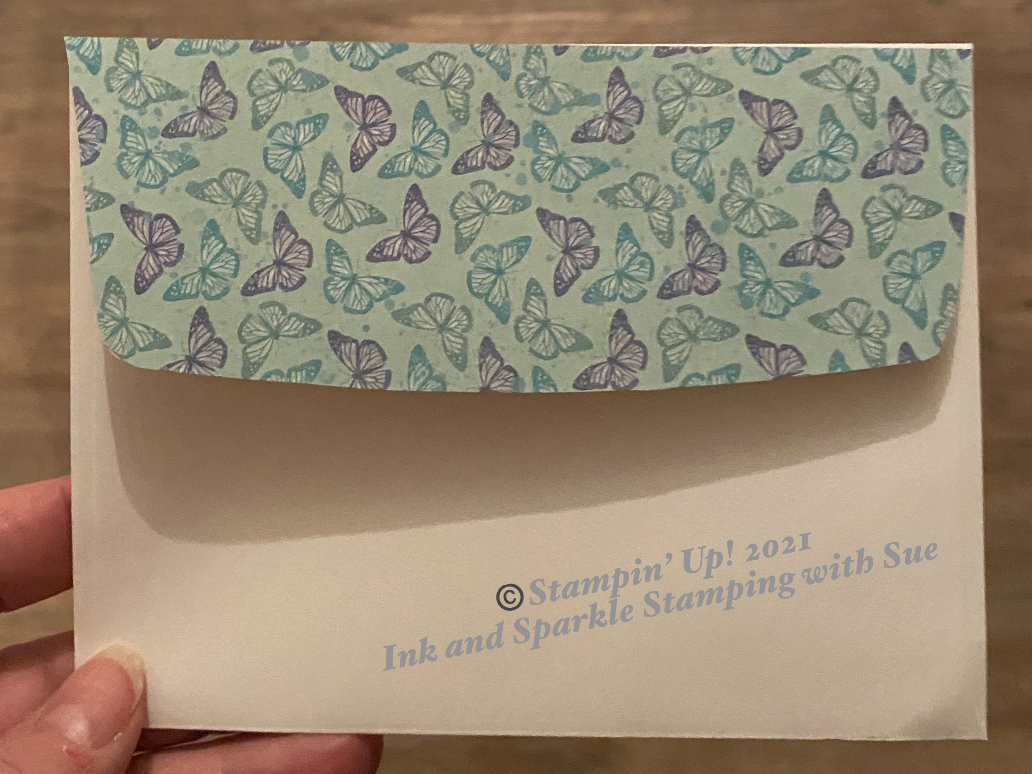
- Using Misty Moonlight ink, stamp the greeting on the inside Basic White layer. Add ink to the smaller butterfly (I cut this bottom right butterfly off the full, multi-butterfly stamp but you don’t necessariy need to do this) and stamp near the center of the bottom edge of the inside layer. Without reinking, huff you breath just above the stamp and restamp the butterfly again slightly angled towards the right edge of the paper and slightly above the first stamped butterfly.
- Add Stampin’ Seal to the top side of the envelope flap and lay the 6” x 2-1/2” piece of Butterfly Bijou DSP over the envelop flap. Turn the flap over and, using Paper Snips, trim the excess from the flap.
- Add a personalized greeting to you card and enjoy sending your project to someone special.

