Garden Wishes 3-2-1 Stamp FaceBook Live
Weds March 31, 2021

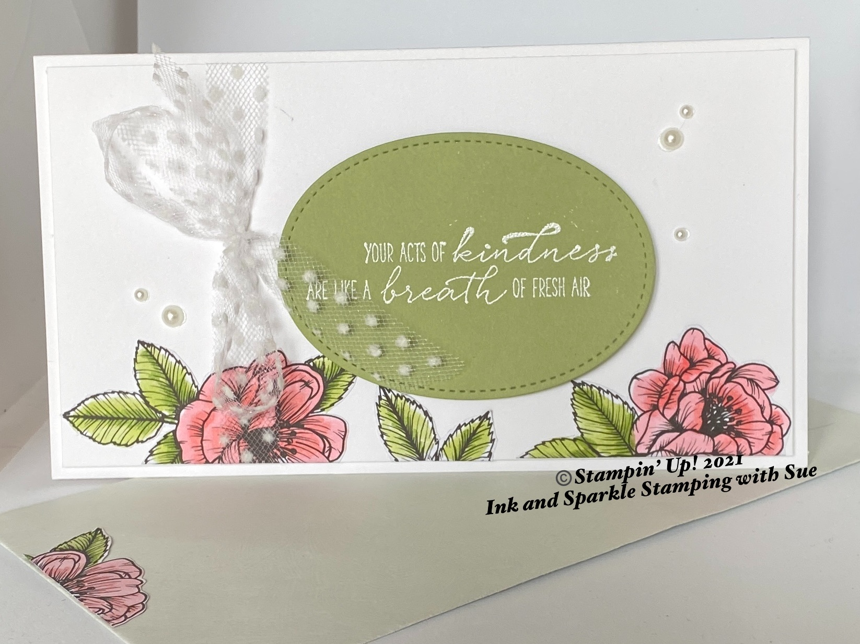

Stamp Sets
- Garden Wishes (154508)

Ink, Markers, & Other Colouring Options
- Whisper White Craft Ink Pad (147277)

Cardstock, Designer Series Paper, etc.
- Thick Basic White (159276)
- Pear Pizzaz (131201)
- True Love Designer Series Paper/DSP (154281)
- #7 Monarch size envelope or handmade envelope
All images © 1990-2021 Stampin’ Up!®

Accessories
- White Embossing Powder (109132); Heat Tool (129053); 5/8” Polka Dot Ribbon (146912)
- Stampin’ Blends Combo Packs: Flirty Flamingo (154884) & Granny Apple Green (154885)
- Pearl Basic Jewels (144219)
- Stitched Shapes Dies (152323); Cut & Emboss Machine (149653) or Mini (150673)
- Adhesives: Black Dimensionals (150893); Stampin’ Seal (152813); Paper Snips (103579)

Measurements:
- Thick Basic White Card Base: see #1 below for cutting tips; 7-1/2” x 6-3/4”, 6-1/2” x 3-1/2”
- Pear Pizzaz: 3” x 4-1/4”

Instructions:

- This card easily cuts from one piece of 8-1/2” x 11” cardstock. With the 8-1/2” side at the top of your paper trimmer, cut at 6-3/4”. Use the 1-3/4” x 11” piece on another project. Cut the remaining 3-1/2” x 6-3/4” down to 3-1/2” x 6-1/2”.
- Trim the desired pieces from the edge of the True Love Designer Series paper of your choice (see picture for suggested images) and colour with Stampin’ Blends as desired. Using Stampin’ Seal, adhere these images to the bottom edge of the 3-1/2” x 6-1/2” piece of Thick Basic White. Cut out an additional flower spray for the inside of the card and front of envelope if desired.
- Using Whisper White craft ink, stamp your desired greeting onto the piece of Pear Pizzaz, sprinkle with White Embossing Powder; shake off excess and heat with the Heat Tool until all of the embossing powder has melted. Cut out the greeting using the largest stitched oval die using your Cut & Emboss machine.
- Use Stampin’ Dimensionals to adhere the Pear Pizzaz layer onto the 3-1/2” x 6-1/2” layer.
- Tie a Polka Dot ribbon bow around the left side of this same panel (see picture).
- Add several Pearl Basic Jewels (see picture).
- Add your personalized greeting to the inside of the card; stamp an envelope as desired and give to someone special in your life. Everybody needs a little love in their mailbox!

Here is an alternative using the retired Feb/March 2021 Sale-A-Bration DSP (Paper Blooms), Night of Navy Ink (147110) and So Sentimental (151691 pg 74 of the current Annual Catalogue but on the Retired List as “while supplies last!).

