3-2-1 Stamp FaceBook Live Weds March 24, 2021
Welcoming Window Bundle

Stamp Sets
- Welcoming Window Bundle (159529)

Ink, Markers, & Other Colouring Options
- Pear Pizzaz Ink Pad (147104)
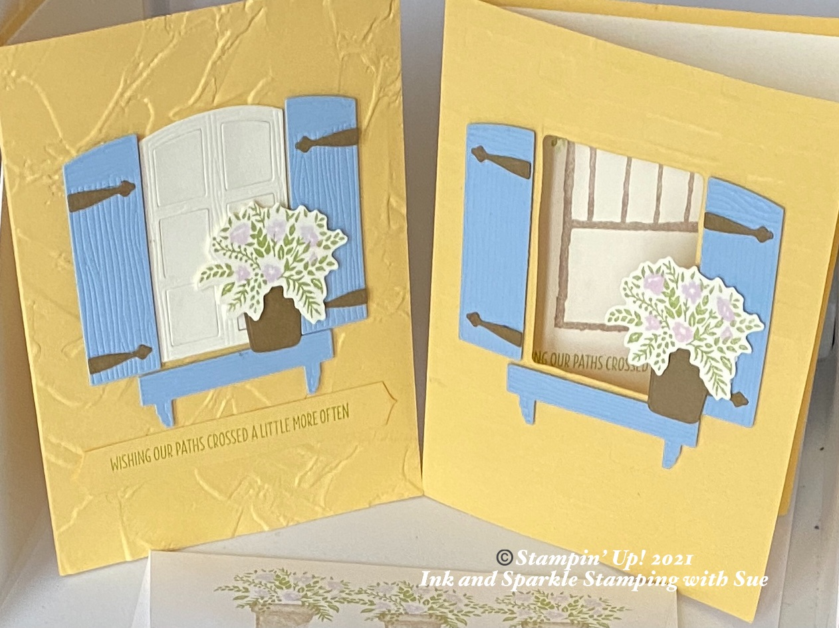
- Crumb Cake Ink Pad (147116)

Cardstock, Designer Series Paper, etc.
- So Saffon (105118)
- Seaside Spray (150883)
- Soft Suede (115318)
- Very Vanilla (101650)

Accessories
- Folders: Brick & Mortar (149643); Painted Texture
(154317)
- Adhesives: Mini Dimensionals (144108); Stampin’
Dimensionals (104430); Stampin’ Seal (152813);
Mini Glue Dots (103683)
- 2019-2021 In-Colour Stampin’ Write Marker
All images © 1990-2021 Stampin’ Up!® Assortment (15007); Wink of Stella (141897)

Measurements:
- So Saffron Card Base: 2 pieces: 8-1/2” x 5-1/2”, plus 1/2”x 4” plus for greeting on 2nd card
- Seaside Spray: 2 pieces of 3” square
- Very Vanilla: 2 pieces of 4” x 5-1/4”, one piece at 2” x 3” plus 2 scraps for flower bunch
- Soft Suede: 1-1/2” x 2-1/2”

Instructions for Card !:

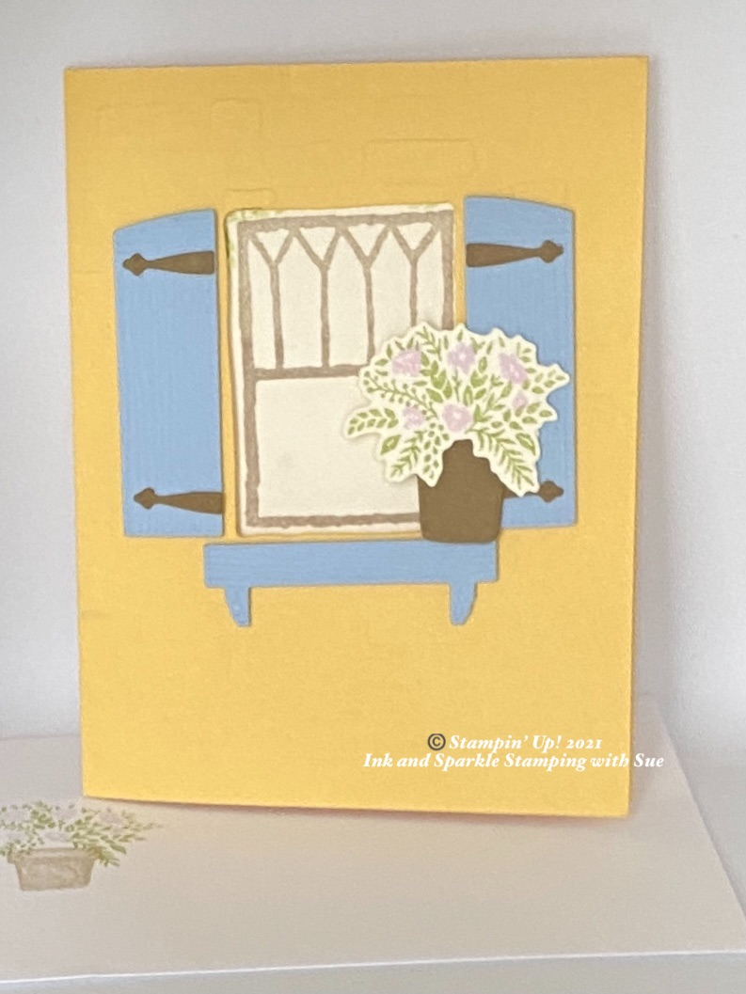
- Run the front of the card base through the Cut & Emboss Machine using the Brick & Mortar Embossing Folder.
- Cut out a window in the top 1/3 of the card front using the 1-3/4” x approx. 2-1/2” rectangle die.
- Cut out the window shutters and flower box dies on the 3” square piece of Seaside Spray.
- Using the hinge and largest flower pot dies, cut these shapes from the piece of Soft Suede.
- Using Pear Pizzaz ink, stamp the leaf spray on a scrap of Very Vanilla and, using the Purple Posy marker, apply ink to the coordinating flower spray stamp and stamp in the opening of the fern shaped leaf spray. Cut out using the coordinating die.
- Gently roll a Mini Glue dot and apply to the back of each of the 4 hinges and apply 2 hinges to each Seaside Spray shutter. Using Stampin’ Dimensionals, adhere the 2 shutters to the front of the card, positioning slightly to the right and left of the opening in the front of the card.
- Using 4 Mini Stampin’ Dimensionals, adhere the flower box under the opening on the card front.
- Apply Stampin’ Seal adhesive on the back of the right side of the flower pot and glue to the left side of the right shutter panel. Add Mini Stampin’ Dimensionals to the back of the right side of the flower spray and adhere just above the flower pot so that the bottom leaves hang over the front of the pot.
- Adhere the 4” x 5-1/4” Very Vanilla panel inside the card. Apply Crumb Cake ink to the rectangular window pane stamp and stamp the image through the opening on the card front onto the Very Vanilla inside liner. Using Pear Pizzaz ink, stamp the “Wishing Our Paths Crossed A Little More Often” verse below the window pane stamp on the inside of the card. Stamp the corner leaf sprays to the top right and top left of the window pane using Pear Pizzaz ink, stamping off a second image of each spray if desired.
- Add your personalized greeting to the inside of the card; stamp an envelope as desired and give to someone special in your life. Everybody needs a little love in their mailbox!

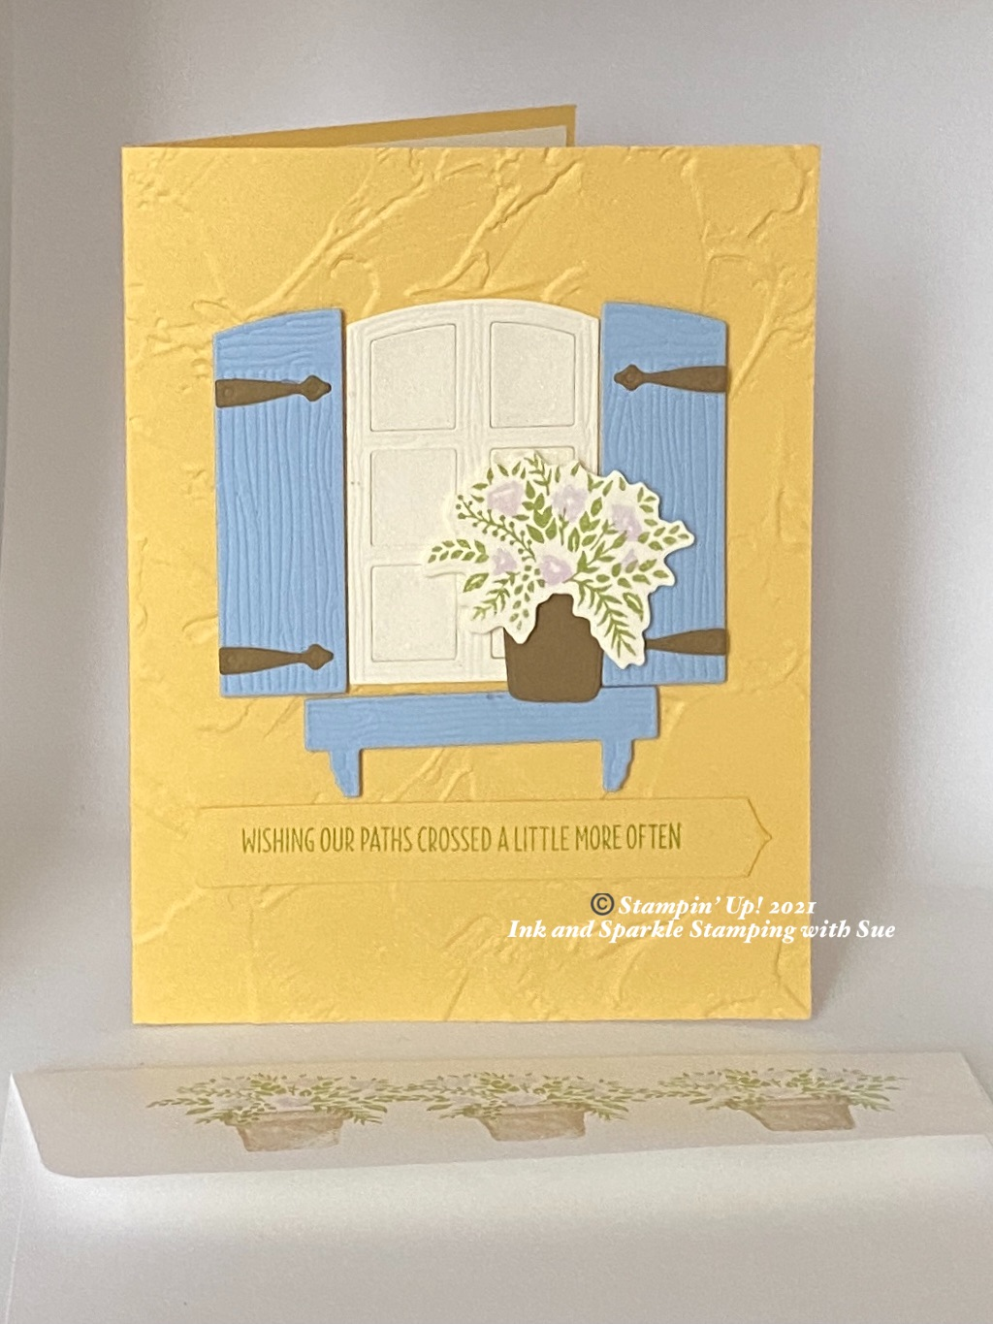
Instructions for Card 2:
- Run the front of the card base through the Cut & Emboss Machine using the Painted Texture Embossing Folder.
- Cut out the 2 shutters and flower box from the Seaside Spray cardstock using the matching dies.
- Using the hinge and largest flower pot dies, cut these shapes from the piece of Soft Suede.
- Using Pear Pizzaz ink, stamp the leaf spray on a scrap of Very Vanilla and, using the Purple Posy marker, apply ink to the coordinating flower spray stamp and stamp in the opening of the fern shaped leaf spray. Uut out using the coordinating die.
- Cut the window pane shape from the Very Vanilla cardstock using the window pane die. Keep the 6 pieces from the inside of the pane.
- Using Stampin’ Seal, adhere the window pane to the front of the card, slightly up from the center. Glue the 6 pieces back into the window pane panel using Stampin’ Seal. Apply Wink of Stella to the 6 panels of the window pane.
- Gently roll a Mini Glue dot and apply to the back of each of the 4 hinges and apply 2 hinges to each Seaside Spray shutter. Using Stampin’ Dimensionals, adhere the 2 shutters to the front of the card, positioning slightly to the right and left of the window pane on the front of the card.
- Using 4 Mini Stampin’ Dimensionals, adhere the flower box under the opening on the card front.
- Apply Stampin’ Seal adhesive on the back of the just at the bottom of the flower pot and add a Stampin’ Dimensional to the top of the flower pot; glue to the left side of the right shutter panel and just a smidge onto the top of the flower box. Add Mini Stampin’ Dimensionals to the back of the of the flower spray and adhere just above the flower pot so that the bottom leaves hang over the front of the pot.
- Adhere the 4”x5-1/4” Very Vanilla to the inside of the card. Stamp a flower pot and spray of leaves and flowers on this panel. Add another flower pot with spray of leaves and flowers to the front of the envelope and/or the envelope flap.
- Add your personalized greeting to the inside of the card; stamp an envelope as desired and give to someone special in your life. Everybody needs a little love in their mailbox!

