3-2-1 Stamp FaceBook Live Weds April 7, 2021

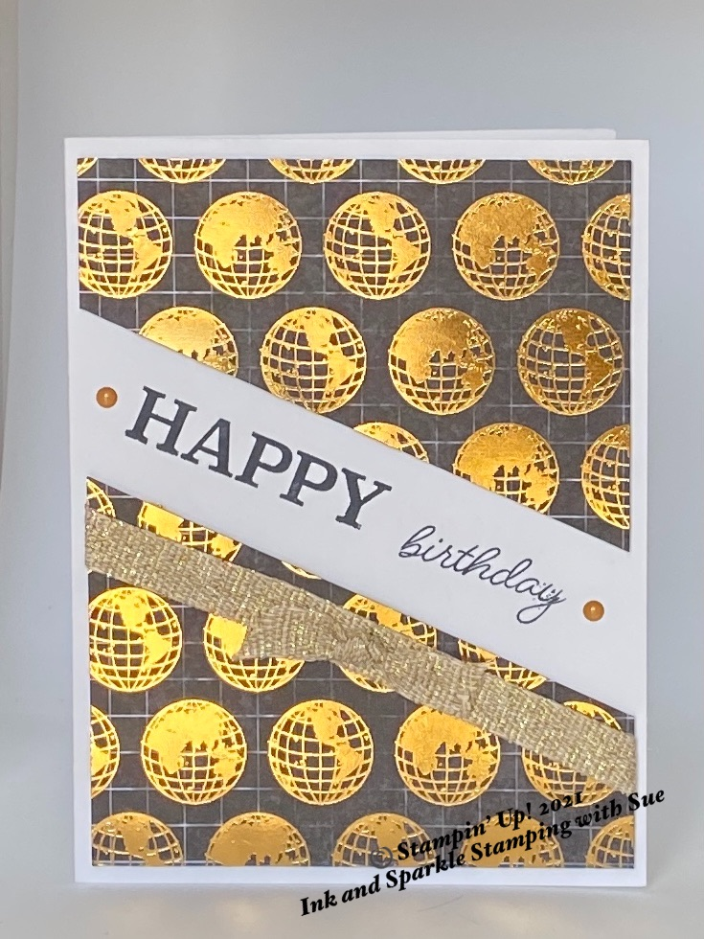
Stamp Sets
- So Much Happy (152624)

Ink, Markers, & Other Colouring Options
- Tuxedo Black Memento Ink Pad (132708)

Cardstock, Designer Series Paper, etc.
- Thick Basic White (159229)
- World Of Good Specialty Designer Series Paper (152491)

Accessories
- Adhesives: Dimensionals (104430); Stampin’ Seal (152813)
- Mini Glue Dots (103683)
- Fine Art 3/8” Gold Ribbon (154561)
- 2020-2022 In Color Enamel Dots (152480)

All images © 1990-2021 Stampin’ Up!®

Measurements:
- Thick Basic White Card Base: 8-1/2” x 5-1/2”, scored at 4-1/4” on the long side
- World of Good DSP: 4” square
- Fine Art Gold Ribbon: 6” plus 3” for knotted bow

Instructions:

- Place the piece of DSP in your Paper Trimmer so that the bottom right corner is on the 1” mark to the right of the trimmer track; move the top left edge of the DSP to the 1” mark on the left of the trimmer track and cut through at this angle (choose any other angle you wish if you prefer).
- Wrap the 6” piece of ribbon diagonally across the bottom piece of DSP and add Stampin’ Seal to the back of the excess on either side of the DSP and adhere to the back of this piece. Make a simple knot in the 3” piece of ribbon and, using a Mini Glue Dot, adhere to the centre of the ribbon.
- Add several (I used 6) dimensionals to the back of the two panels of the DSP. See picture for placement of these panels on the card front.
- Using Tuxedo Black Memento Ink, stamp the “Happy” and “birthday” in the gap between the 2 pieces of DSP (see picture for placement).
- Add a Cinnamon Cider coloured Enamel Dot to the left and right of the greeting.
- Add your personalized greeting to the inside of the card; stamp an envelope as desired and give to someone special in your life. Everybody needs a little love in their mailbox!

3-2-1 Stamp FaceBook Live Weds April 7, 2021

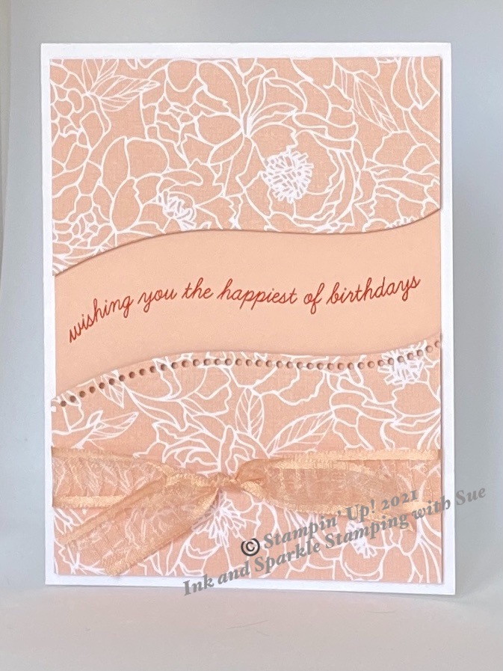
Stamp Sets
- Quite Curvy (154430)

Ink, Markers, & Other Colouring Options
- Poppy Parade Ink Pad (147050)

Cardstock, Designer Series Paper, etc.
- Peony Garden Designer Series Paper (152483)
- Petal Pink Card Stock (146985)

Accessories
- Curvy Dies (154319)
- Adhesives: Dimensionals (104430); Stampin’ Seal (152813)
- Mini Glue Dots (103683)
- Petal Pink Organdy Striped Ribbon (149441)

All images © 1990-2021 Stampin’ Up!®

Measurements:
- Thick Basic White Card Base: 8-1/2” x 5-1/2”, scored at 4-1/4” on the long side
- Peony Garden DSP: 4” square
- Petal Pink Card Stock: 4” x 5-1/4”
- Petal Pink Organdy Ribbon: 22”

Instructions:

- Place the dotted curving die on the piece of DSP approximately 1-1/2” from the top. Run through the Cut and Emboss Machine.
- Wrap the Petal Pink ribbon around the bottom piece of the DSP and tie in front a double knot, centered. Trim the ends of the ribbon as necessary.
- Using Stampin’ Seal, adhere the top and bottom pieces of DSP to the Petal Pink card stock panel.
- Use Poppy Parade Ink and stamp the greeting in the middle of the Petal Pink card stock opening.
- Using Dimensionals, adhere the Petal Pink panel to the front of the card base.
- Add your personalized greeting to the inside of the card; stamp an envelope as desired and give to someone special in your life. Everybody needs a little love in their mailbox!

3-2-1 Stamp FaceBook Live Weds April 7, 2021

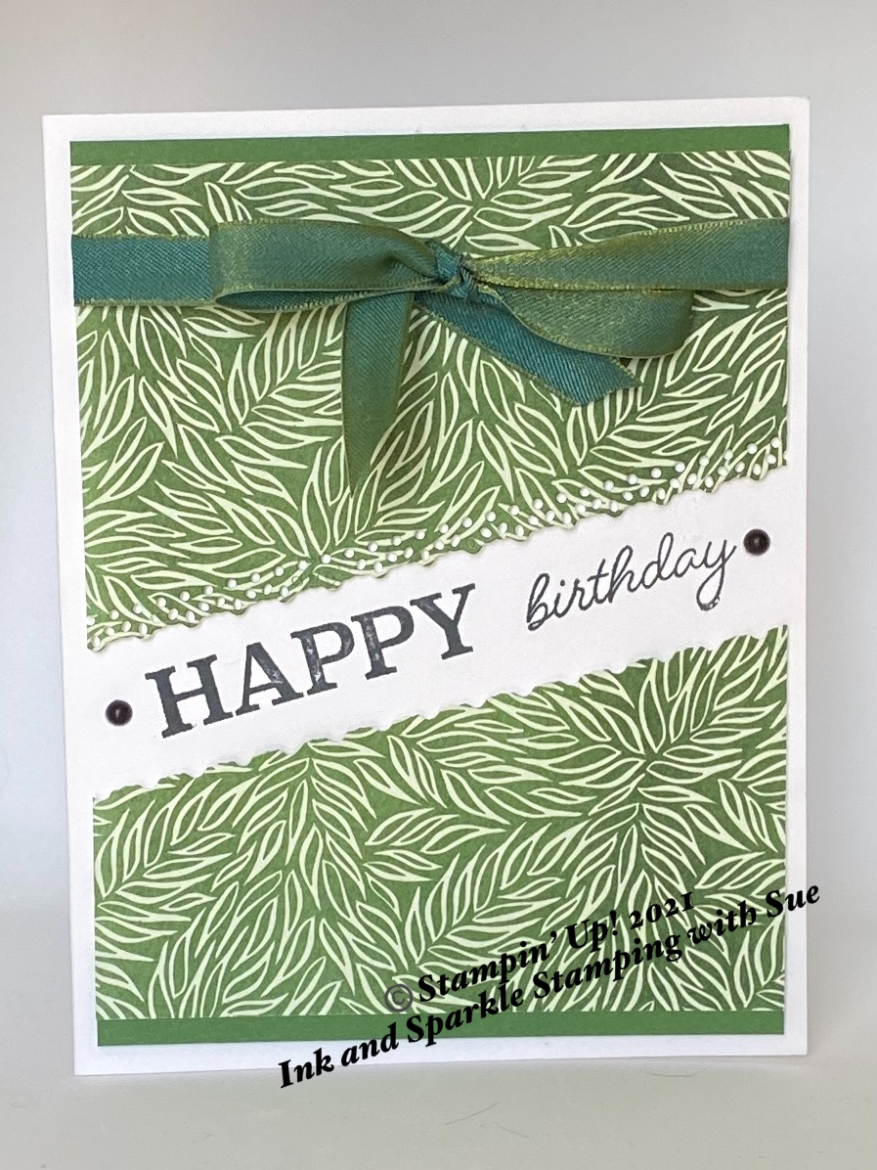
Stamp Sets
- So Much Happy (152624)

Ink, Markers, & Other Colouring Options
- Tuxedo Black Memento Ink Pad (132708)

Cardstock, Designer Series Paper, etc.
- Forever Greenery Designer Series Paper (152492)
- Garden Green Card Stock (102584)

Accessories
- Ornate Layers Dies (152726)
- Adhesives: Dimensionals (104430); Stampin’ Seal (152813)
- Mini Glue Dots (103683)
- Matte Black Dots (154284)
- Old Olive/Pretty Peacock 3/8” Reversible Ribbon (149496)
All images © 1990-2021 Stampin’ Up!®

Measurements:
- Thick Basic White Card Base: 8-1/2” x 5-1/2”, scored at 4-1/4” on the long side
- Forever Greenery DSP: 4” square
- Garden Green Card Stock: 2 pieces of 4” x 1/2”
- Old Olive/Pretty Peacock Ribbon: 22”

Instructions:

- Place the piece of DSP diagonally under the largest rectangle die and run through the Cut & Emboss Machine (see photo).
- Wrap the ribbon around the top piece of the DSP and tie in a bow, centered. Trim the ends of the ribbon as necessary. In the video of this card, I cut 4” off the ribbon and then tied a bow in the center of the long piece of ribbon. I wrapped the ends of the ribbon around the right & left sides of the top panel of DSP and adhered on the back with Stampin’ Seal. I then took the 4” piece of ribbon and folded it in half and adhered it under the knot of the bow with Mini Glue Dots. I recommend this method if you are frustrated with a regular bow and keeping the ribbon from slipping.
- Using Dimensionals, adhere the top and bottom pieces of DSP to the Basic White card front.
- Use Tuxedo Black Memento Ink, stamp the “HAPPY” and “birthday” greetings in the middle of the DSP opening.
- Adhere a Matte Black Dot to the right and left side of the greeting.
- Add your personalized greeting to the inside of the card; stamp an envelope as desired and give to someone special in your life. Everybody needs a little love in their mailbox!

