3-2-1 Stamp FaceBook Live Weds April 14, 2021

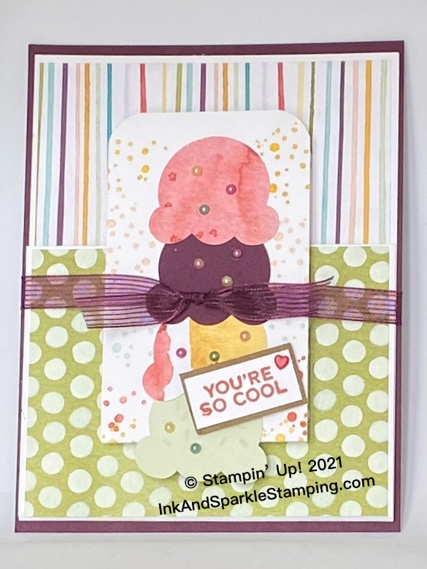
Stamp Sets
- Sweet Ice Cream Bundle including punch (158244)

Ink
- Terracotta (150086); Highland Heather (147103); Pool Party
147107); Crushed Curry (147087)
- Versamark Ink Pad (102283)

Cardstock, Designer Series Paper (DSP), etc.
- Blackberry Bliss (133675); tiny scrap Soft Suede (
- Thick Basic White (159229)
- Ice Cream Corner DSP (154567) plus various cardstock scraps for ice cream scoops (I used So Saffron, Petal Pink, Soft Seafoam, Blackberry Bliss)

Accessories
- Blackberry Bliss Striped Ribbon (154569)
All images © 1990-2021 Stampin’ Up!® Adhesives: Dimensionals (104430); Stampin’ Seal (152813)
          - Resin Hearts Embellisments (154578); retired Share What You
Love Artisan Pearls (146927); Wink of Stella (141897) if desired
Treasured Tags Pick A Punch (154425).

Measurements:
- Blackberry Bliss Card Base: 4-1/4” x 5-1/2”
- Soft Suede: 5/8” x 1-3/8”
- Basic White: 2-1/4” x 11”, 8-3/8” x 4-1/8”, 1” x 4” for inside greeting;
1/2” x 1-1/4” for tiny outside greeting
- Ice Cream Corner DSP: colourful stripes 5-1/8” x 4”, green polka dots 3” x 4”; brown
waffle pattern for waffle cone. plus scraps from other patterns
for 5 ice cream punched shapes
- Blackberry Bliss Ribbon: 12”

Instructions:

- Punch 5 ice cream scoop shapes from 5 different colours of cardstock that complement the colours of the DSP. Punch 5 additional ice cream scoop shapes from various colours of the DSP. Punch the cone shape from the brown waffle weave DSP.
- Score the 2-1/4” x 11” Basic White piece at 3-3/4” and 7-1/2”.
- Score the 8-3/8” x 4-1/8” Basic White piece at 5-1/4” along the long side.
- Adhere the longer side of the Basic White 8-3/8” x 4-1/8” to the Blackberry Bliss piece. Adhere the colourful striped DSP to the larger side of this same Basic White piece. Fold up the bottom of the scored piece and adhere the green polka dot piece to the top of this folded piece.
- Stamp the bubble image in various ink colours onto the right and left edge of the 2-1/4” x 11” piece and fold up (slightly smaller panel goes to the bottom and the front surface folds up from the bottom when folded. Use a corner rounder if desired to round the top right and left corners while this panel is still folded.
- Unfold the piece in #5 above and adhere the cone shape approximately 1/2” from the bottom of the panel. Stamp the sprinkles stamp onto the card stock ice cream scoops using Versamark ink.

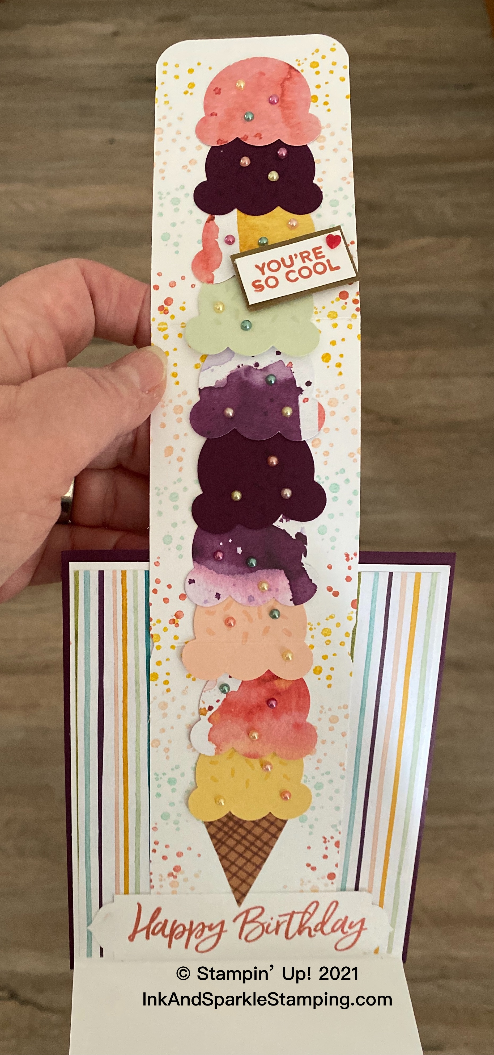
- Adhere the ice cream scoop shapes beginning with a cardstock one and then a DSP one and continue to alternate. Fold cardstock ice cream scoops when adhering to a fold in the Basic White strip. Leave off any adhesive on the back bottom edge of the So Saffron cardstock scoop that overlaps the score mark in the top panel (see picture).
- Add lots of adhesive to the back of the 2-1/4” x 11” strip (see picture for placement).
- Stamp the “Happy Birthday” greeting using Terracotta ink onto the 1” x 4” Basic White piece. Punch both ends o this piece using the Treasured Tags Pick A Punch. Adhere the greeting below the 2-1/4” x 11”strip.
- Stamp the “You’re So Cool” greeting on the 1/2” x 1-1/4” Basic White piece or stamp on a bigger scrap and cut out with paper snips. Adhere to the 5/8” x 1-3/8” piece of Soft Suede.
- Add a tiny red Resin Heart to the “You’re So Cool” greeting on the front. Add as many Share What you Love Artisan Pearls to each of the scoop shapes.
- Add Wink of Stella to the ice cream scoops if desired.
- Add your personalized greeting to the inside flap of the card; decorate an envelope as desired and give to someone special in your life. Everybody needs a little love in their mailbox!

