3-2-1 Stamp FaceBook Live Weds May 5, 2021

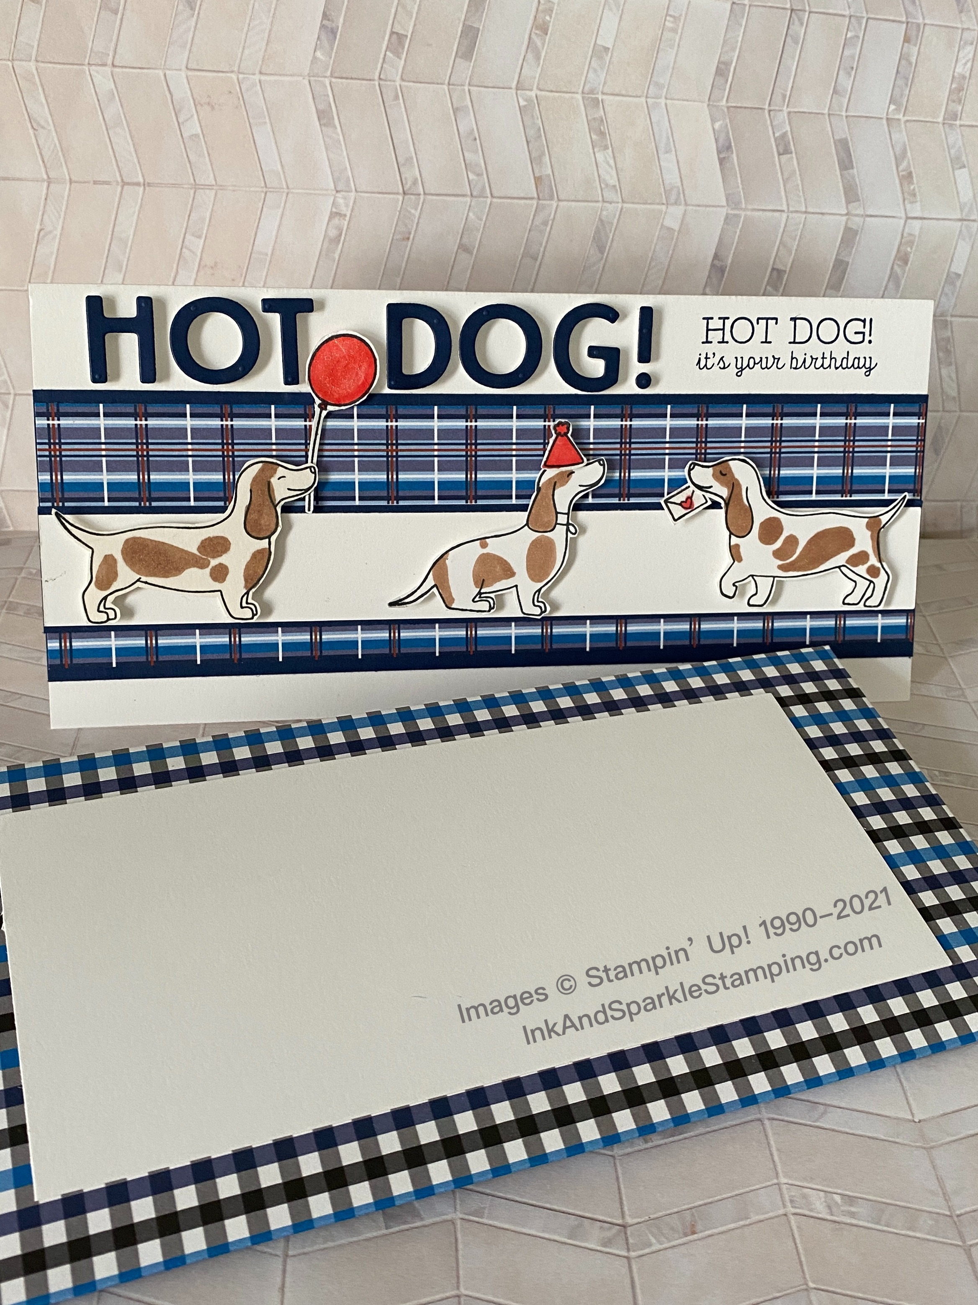
Stamp Sets
- Hot Dog Stamp Set (154497)

Ink, Markers, & Other Colouring Options
- Tuxedo Black Memento Ink Pad (132708)
- Night of Navy Ink Pad (147110)

Cardstock, Designer Series Paper, etc.
- Thick Basic White (159229)
- Night of Navy (100867)
- Well Suited Designer Series Paper (154562)

Accessories
- Playful Alphabet dies (152706); Wink of Stella Glitter Brush
(141897); Poppy Parade Blends Combo (154958); Bronze & Ivory
Blends Combo (154922); Dimensionals (104430); Mini Glue Dots
(103683); Stampin’ Seal (152813); Foam Adh Sheets (152815)
All images © 1990-2021 Stampin’ Up!®

Measurements:
- Thick Basic White Slimline Card Base: 8” x 8-1/2”; 1” x 8-1/2”; 3” x 7-5/8”; scraps
- Night of Navy: 2-5/8” x 8-1/2”; 1-1/8” x 8-1/2”; 2” x 4”
- Blue/Poppy plaid/Well Suited DSP: 2-3/8” x 8-1/2”; 9-1/8” x 11” for envelope

Instructions:

- Score the 8” x 8-1/2” Thick Basic White card base at 4” on the 8” side.
- Adhere the strip of DSP to the 2-5/8” x 8-1/2” piece of Night of Navy. Adhere this panel approximately 1/2” from the bottom of the card front.
- Adhere the Thick Basic White 1” x 8-1/2” strip to the 1-1/8” x 8-1/2” strip of Night of Navy and adhere approximately 1-1/4” from top of card base.
- Stamp one of each of the 3 dogs and the party hat, balloon and envelope in Memento ink onto the scrap of Thick Basic White card stock. Colour the balloon, party hat and heart on the envelope with the Light Poppy Parade Blends Marker. Add splotches of colour to the dogs using the Bronze Blends Marker and hand cut the 6 items out.
- Add the 2” x 4” piece of Night of Navy to one corner of a sheet of Foam Adhesive and cut the Foam Adhesive Sheet slightly smaller that the piece of Night of Navy adhered to it.
- Using the Mini or Standard Stampin’ Cut & Emboss Machine, cut the letters of HOT DOG! out of the Night of Navy/Foam Adhesive layer. Use the negative piece for another project if desired.
- Use Dimensionals to adhere the dogs to the bottom of the Thick Basic White strip (see picture). Add Mini Glue Dots or Dimensionals to attach the accessories to the dogs (see picture).
- Remove the backing from the letters and adhere the words “Hot Dog!” as in the picture.
- Using Night of Navy Ink, stamp the “Hot Dog! It’s your birthday” to the top right of the card front, centering between the exclamation point and the right edge of the card front.
- FOR THE ENVELOPE: Take the 9-1/8” x 11” piece of DSP and score on the 9-1/8” side at 2” and 6-1/8”. Score the 11” side at 1-1/4” and 10”. Remove the 4 corners with Paper Snips, following the score lines. Adhere at the overlying portions after inserting your card. Adhere a 3” x 7-5/8” piece of Thick Basic White card stock to the centre of the front of the envelope and use this to address return and to addresses.
- Everyone needs a little love in the mailbox! Project CASE’d from Stampinhoot.com.

