Hand-Penned Memories & More Cards - A Wish for Everything

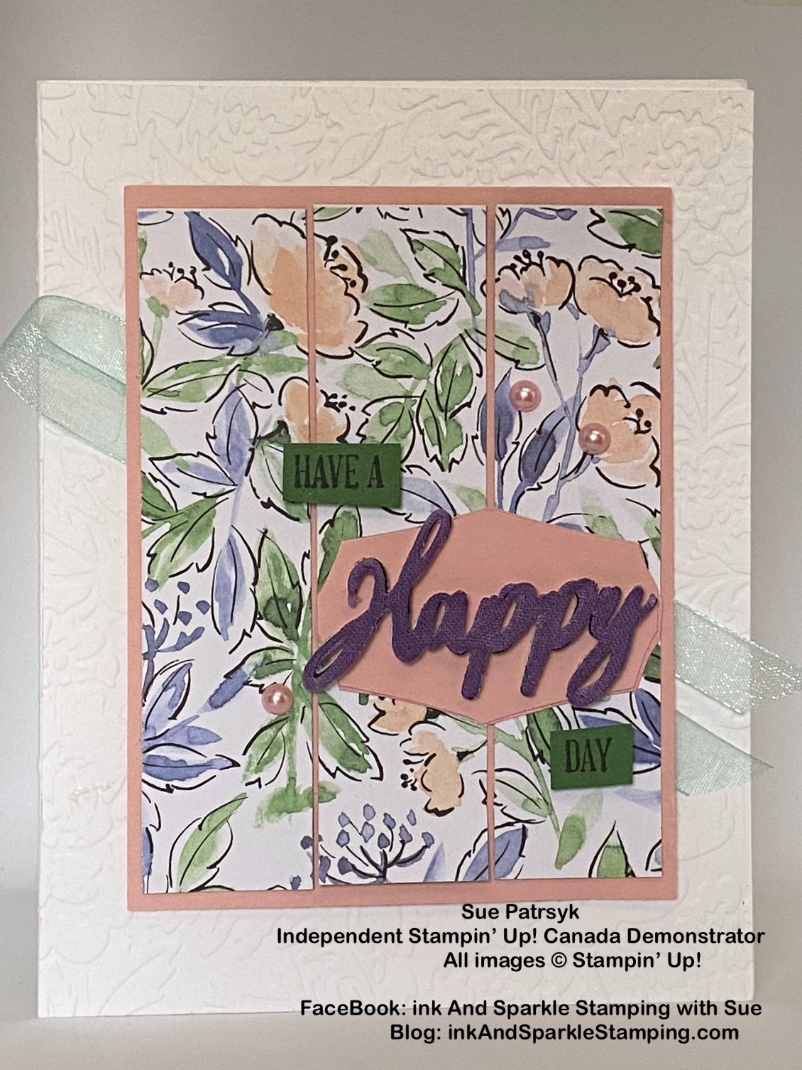
Stamp Sets – A Wish for Everything Bundle (149320)

Card Stock –Thick Basic White (159229); Blushing Bride (131198); Basic Black (121045); Garden Green (102584)

Stamp Pads – Tuxedo Black Memento Ink (132708)

Misc. – Linen Specialty Paper (155681); Word Wishes Dies (149629); Pretty Flowers Embossing Folder (155428); Hand-Penned Memories & More Card Pack (155505); Pool Party 3/8” Sheer Ribbon (152462); Highland Heather Blends Combo (154887); Pastel Pearls (154571); Foam Adhesive Sheets (152815); Mini Dimensionals (144108); Stampin’ Seal (152813); Mini Glue Dots (103683); Paper Snips (103579); Stampin’ Cut & Emboss Machine (149653) or Mini Stampin’ Cut & Emboss Machine (150673)

All images © 1990-2021 Stampin’ Up!®

Measurements:
- Thick Basic White Card Stock: 8 1/2” x 5 1/2” scored at 4 1/4” on the long side
- Blushing Bride Card Stock: 3 3/8” x 4 1/4”
- Linen Specialty Paper: 1 1/2” x 2 1/4” scrap
- Basic Black Card Stock: 1 1/2” x 2 1/4” scrap
- Garden Green Card Stock: 1/2” x 1 1/2” scraps
- Hand-Penned Memories & More Card Pack (3” x 4” panel of choice)
- Pool Party Sheer Ribbon: 12”

Instructions:
- Emboss front of Basic White card base with the Pretty Flowers Embossing folder.
- Cut the Memories & More 3” x 4” card of your choice into 3 strips of 1” x 4”.
- Adhere the two outside panels of the 1” x 4” strips to the right and left side of the Blushing Bride panel with Stampin’ Seal.
- Adhere the center strip of 1” x 4” centered between the other two panels.
- Stamp the words “Have A” and “Day” onto Garden Green card stock using Tuxedo Black Memento Ink. Cut out the words using Paper Ships.
- Remove the Blushing Bride tag from the sticker sheet included with the Memories & More Card Pack and adhere to the right side of the panel (it is self-adhesive).
- Remove the backing of one side of the Foam Adhesive Sheet and adhere the scrap of Basic Black card stock to that side.
- Cut out the word “Happy” from the Word Wishes die set from the Basic Black/Foam piece.
- Colour the Linen Specialty Paper scrap with the Dark Highland Heather Blends marker and then cut the word “Happy” out with the coordinating die.
- Adhere the Highland Heather “Happy” to the top of the Basic Black/Foam Strip “Happy” taking care to let the black card stock show through slightly, creating a shadow effect.
- Remove the backing from the Basic Black/Foam layer and adhere onto the top of the Blushing Bride tag.
- Add Mini Dimensionals to the back of “Have A” and “Day” stamped pieces and adhere to the front of the card (see picture for placement).
- Loop the Pool Party ribbon in half and adhere to the back of the Blushing Bride panel.
- Add Stampin’ Dimensionals to the back of the Blushing Bride panel and adhere to the Basic White card base.
- Add 3 Pastel Pearls (pink colour) to the front of the card.
- Enjoy adding your personal greeting and send to someone special.special in your life. Everybody needs a little love in their mailbox!

