3-2-1 Stamp Sept 15, 2021
(CASED from Leena Girsa) Hinge Stamping

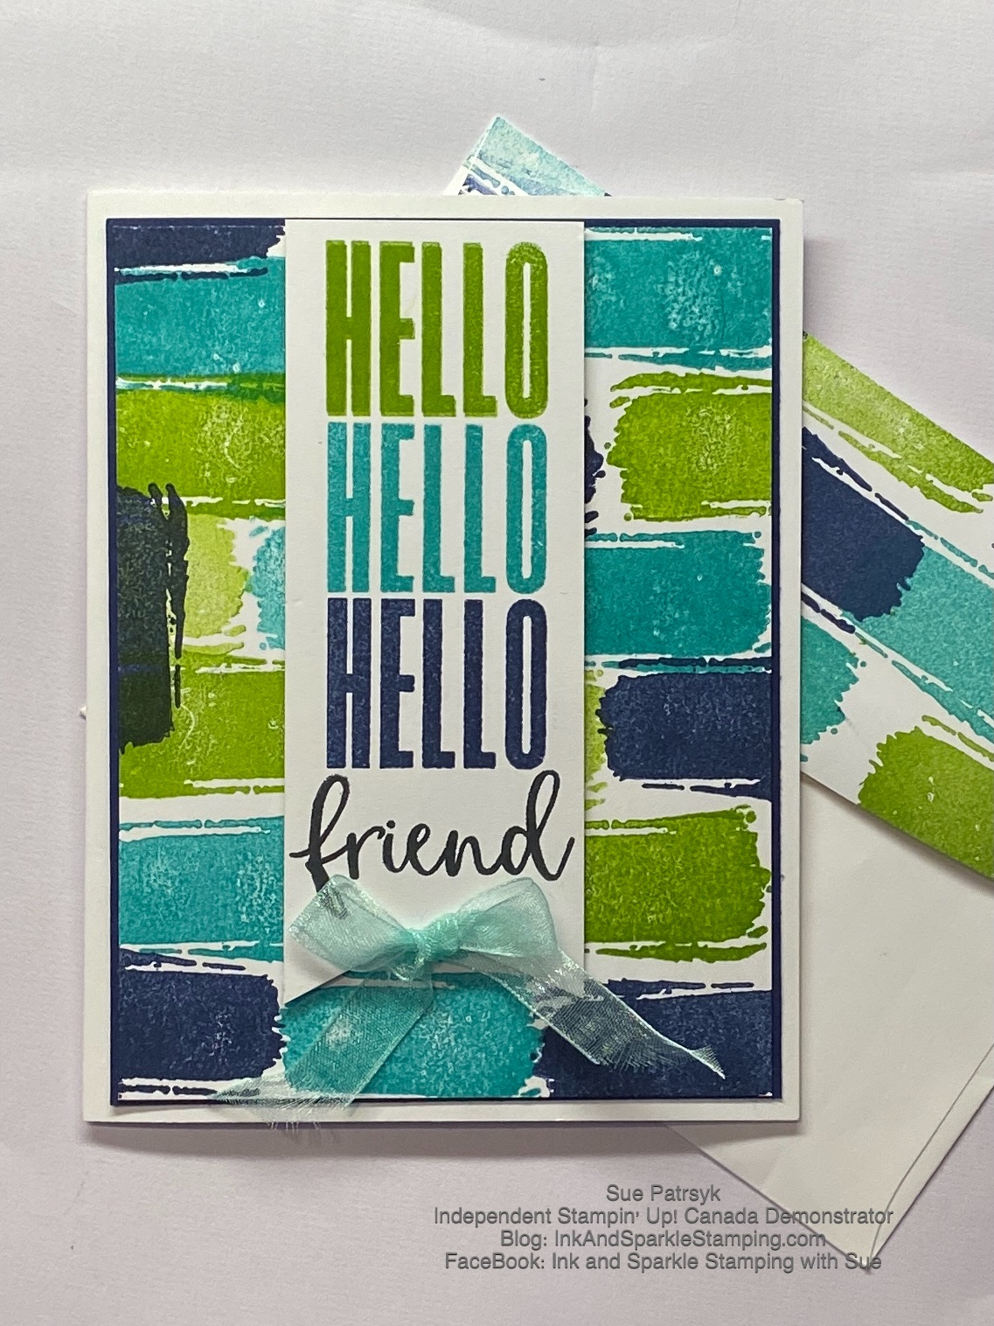All images © 1990-2021 Stampin’ Up!® | Stamp Sets  - Textures & Frames (SAB 156616)  - Biggest Wish (155052)  Ink, Markers, & Other Colouring Options  - Granny Apple Green Ink Pad (147095)  - Bermuda Bay Ink Pad (147096)  - Night of Navy Ink Pad (147110)  - Tuxedo Black Memento Ink Pad (132708)  Cardstock, Designer Series Paper, etc.  - Basic White Thick Cardstock (159229)  - Night of Navy( Cardstock156824)  Accessories  - Stampin’ Seal (152813); Mini Glue Dots (103683); Stampin’ Dimensionals (104430)  - Stamparatus (146276); Simply Shammy (147042)  - Tailored Tag Punch (145667)  - Pool Party Sheer Ribbon (152462); retired Night of Navy Thick Bakers Twine used for alternative sample

Measurements:  - Thick Basic White Card Stock:  - Night of Navy Card Stock:  - Pool Party Sheer Ribbon: | 8-1/2” x 5-1/2”; 3-7/8” x 5-1/8”; 1-3/4” x 4-5/8”  4” x 5-1/4”  10”

Instructions:
- Using the Tailored Tag Punch, flag the end of the 1-3/4” x 4-5/8” piece of Thick Basic White Card Stock.
- Stamp the word “friend” from the Biggest Wish Stamp set at the bottom of this banner using Tuxedo Black Memento Ink.
- Add the banner to the Stamparatus near the middle so that you have room to stamp and then move the hinge of the acrylic plates down (see video for more detail). Keep the acrylic plate in the left set of hinges.
- Position the “HELLO” stamp from the Biggest Wish Stamp Set upside down and centered approximately 1/8” from the top of the banner.
- With the acrylic plate in the top hinge, swing down over card and press into the back of the stamp so that the stamp transfers to the acrylic plate.
- Add Granny Apple Green Ink to the “HELLO” stamp and stamp onto the top of the banner using the Stamparatus.
- Wipe off the ink on the stamp using your Stampin’ Shammy (you will see in the video that I cut one of my Simply Shammy sheets into quarters and used this to wipe the ink from the stamp).
- Move the acrylic plate on the Stamparatus one hinge downward but do not reposition the stamp itself on the acrylic plate.
- Add Bermuda Bay Ink to the “HELLO” stamp and stamp onto the banner piece (see video).
- Repeat the cleaning and reinking with Night of Navy Ink. The Night of Navy “HELLO” will be approximately 1/8” above the stamped word “friend”. Set the banner piece aside for now.
- Take the 3-7/8” x 5-1/8” piece of Thick Basic White card stock and use the rectangle stamp from the Textures & Frames stamp set: I started with the Night of Navy Ink and randomly stamped repeatedly (see photo or video). Remember to stop off the edge of the card stock sometimes and remember that the banner piece will cover some of the stamping you do on this layer.
- Clean the stamp on the Simply Shammy and stamp the same image with Bermuda Bay Ink (see photo or video for placement if desired).
- Clean the stamp on the Simply Shammy and stamp the same image with Granny Apple Green Ink (see photo or video for placement if desired).
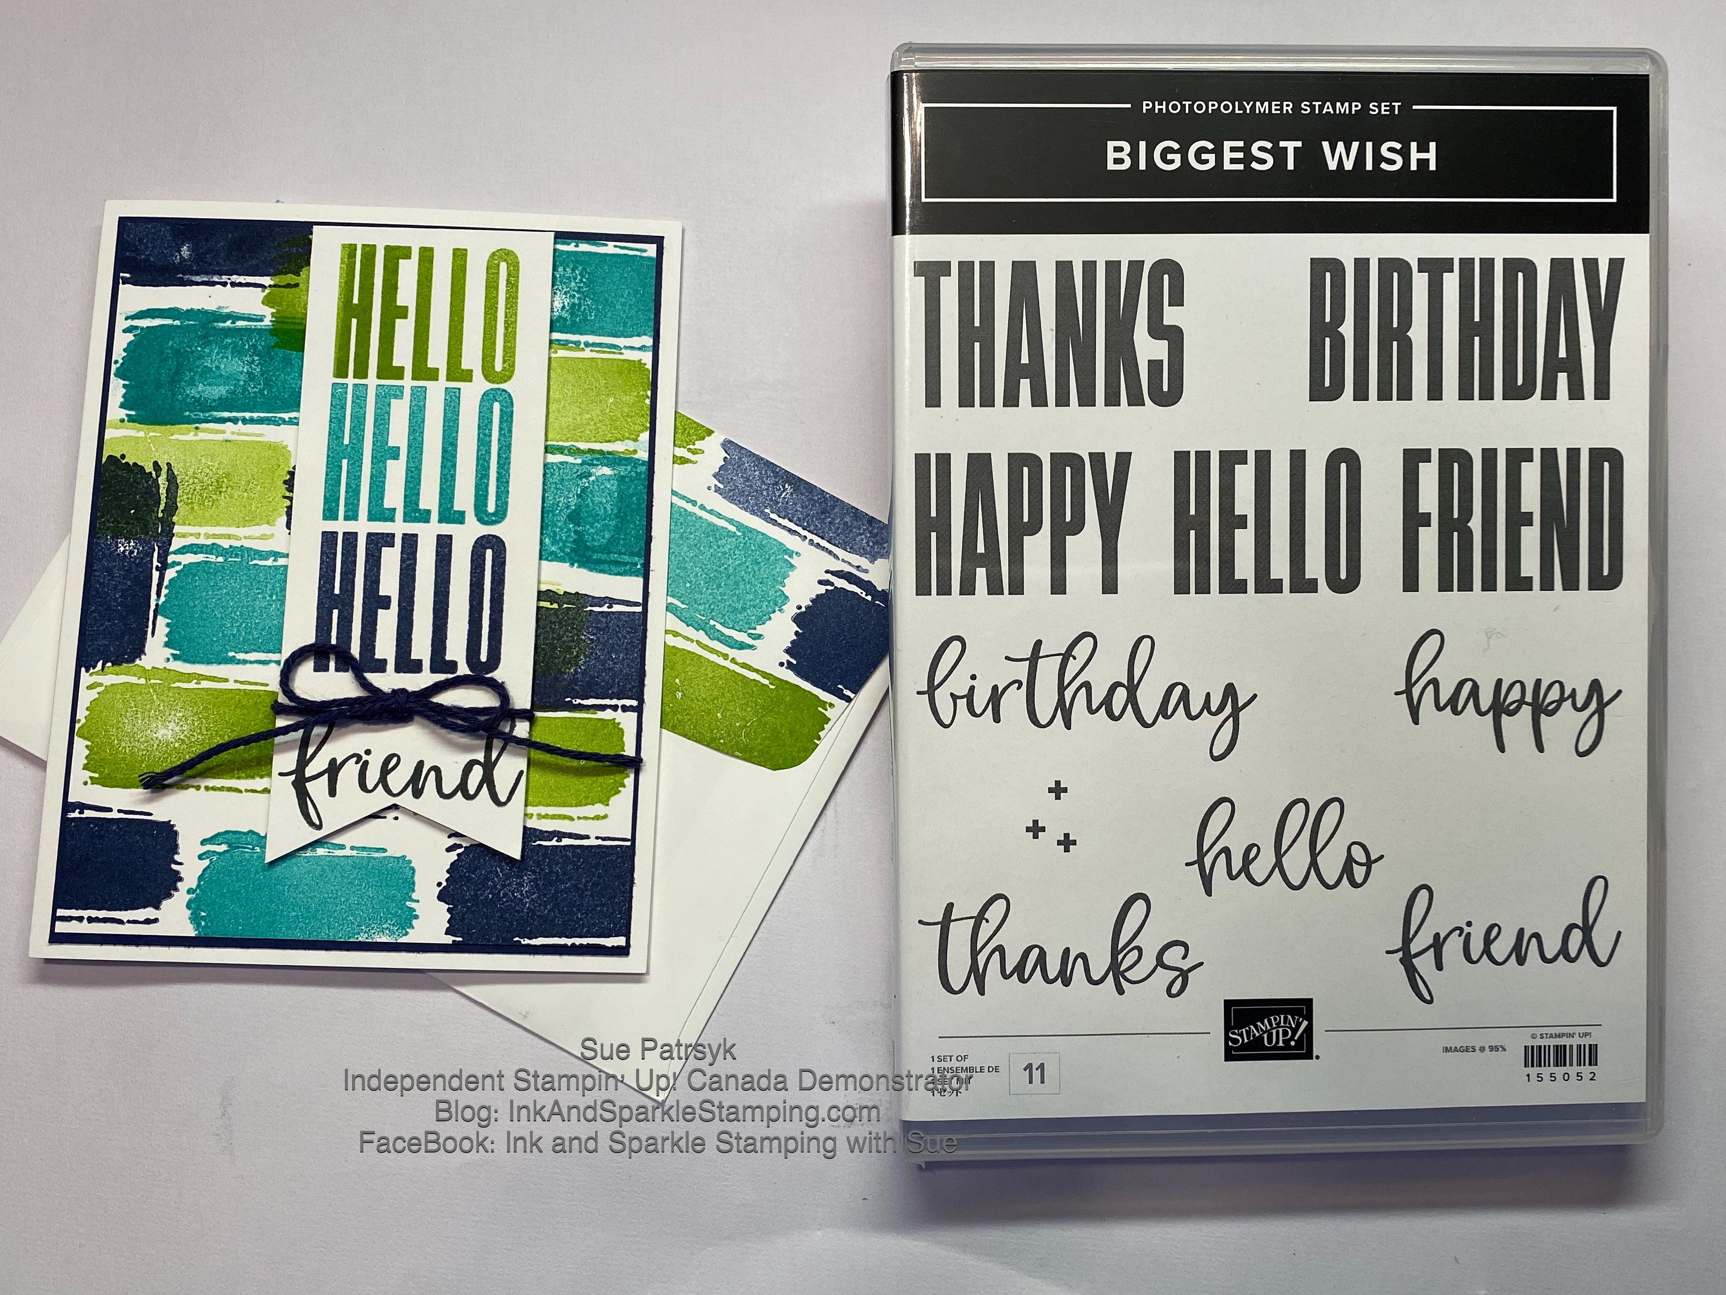
- Add Stampin’ Seal to the back of the panel stamped in Step 13 and adhere to the panel of Night of Navy card stock.
- Add the panel in Step #14 to the card base using Stampin’ Seal.
- Add Stampin’ Dimensionals to the back of the banner piece and adhere to the front of the card - in one example I centered this on the front and on another one, I adhered it slightly off center -- you decide where you’d like this banner to go.
- Tie a small bow with the Pool Party Sheer Ribbon and add to bottom of the banner using Mini Glue Dots. This photo shows alternative with retired Night of Navy Thick Baker’s Twine.
- Add the greeting of your choice to the inside of the card send to someone special. Everyone deserve some happy mail!

