Love & Happiness Z-Fold Card

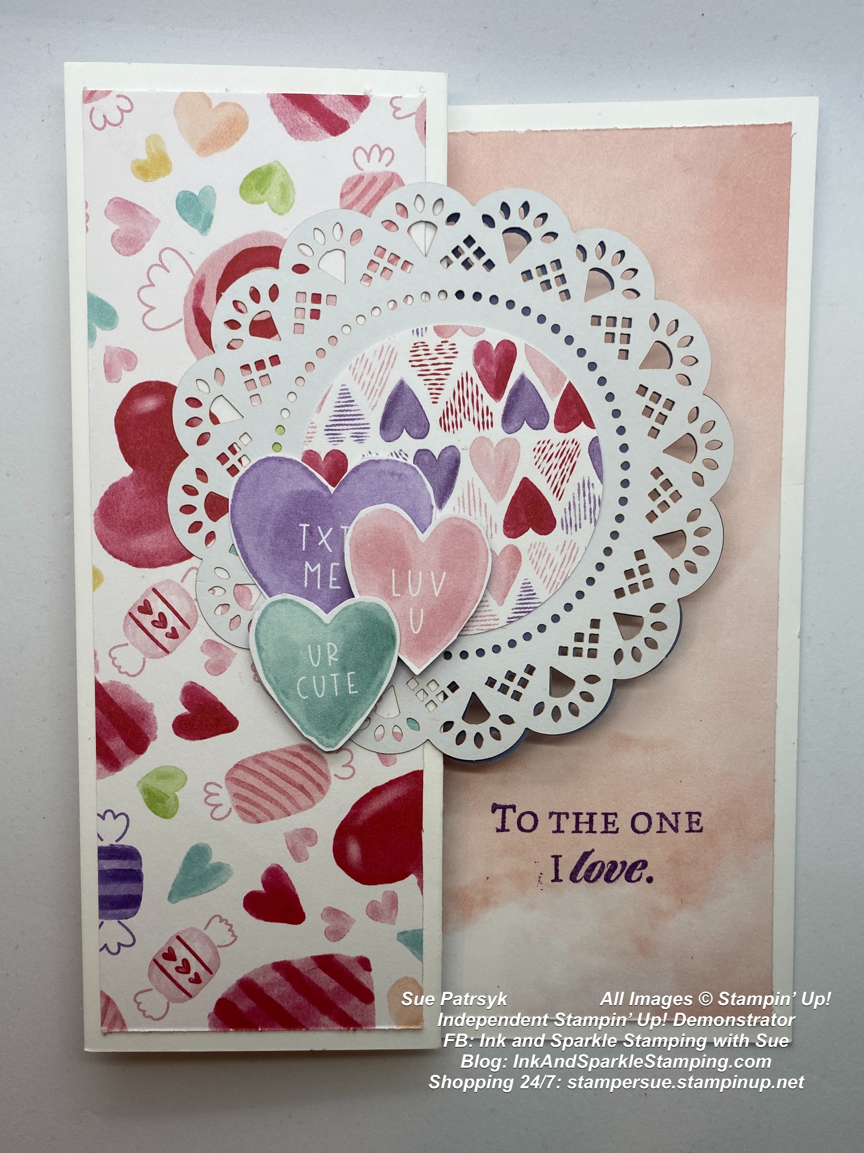  All images © 2022 Stampin’ Up!® | Stamp Sets  Love & Happiness Stamp Set (157633)  Ink, Markers, & Other Colouring Options  - Gorgeous Grape Ink (147099))  Cardstock, Designer Series Paper, etc.  - Thick Basic White (159229)  - Sweet Talk Designer Series Paper (DSP) (157616)  Accessories  - Stampin’ Seal (152813); Stampin’ Dimensionals (104430)  - 2020- Heart & Home Doilies (157956)  - Layering Circles Dies (151770)  - Paper Snips Scissors (103579)

Measurements:  - Thick Basic White card base:  - Sweet Talk DSP Pattern 1  - Sweet Talk DSP Pattern 2:  - Sweet Talk DSP Pattern 3:  - Sweet Talk DSP Pattern 4:  - Heart & Home Doilies: | 8-1/2” x 5-1/2“  1-7/8” x 5-1/4”, 4” x 5-1/4”  1-7/8” x 5-1/4”  Scrap to die cut 4th smallest circle die (approx 1 3/4”)  Scrap to hand cut 3 heart images  2 pieces

Instructions:
- On the long side of the Thick Basic White card base, score at 2” and 4”. Fold the 4” score towards the right and then fold the 2” score mark back towards the left of the card base.
- Use Stampin’ Seal to adhere the 1 7/8” x 5 1/4” panel of Pattern 1 of the DSP to the front of the Z fold. Use Stampin’ Seal to adhere the 1 7/8” x 5 1/4” panel of Pattern 2 of the DSP to the inside of the Z fold. Use Stampin’ Seal to adhere the 4” x 5 1/4” panel of Pattern 1 to the inside of the card.
- Use the 4th smallest circle die to cut the approx 1 3/4” circle from Pattern 3 of the DSP.
- Use Stampin’ Seal to adhere the circle die cut to the centre of one of the doilies on the white side.
- Add Stampin’ Seal only to the left side of this doily and adhere slightly above center on the front of the Z-part of the card front.
- Add Stampin’ Seal to the coloured side of the 2nd doily and adhere to the inside of the Z-part of the card front so that the scallops of the doilies match up.
- Cut 3 heart images from the scrap of DSP (1 large and 2 medium). Use Stampin’ Seal to adhere the large heart to the lower left area of the die cut circle.
- Use Stampin’ Dimensionals to add the 2 remaining medium hearts adjacent to the large heart.
- Using Gorgeous Grape stamp the greeting of your choice on the right lower area of the inside of the card.
- Don’t forget to stamp or add a panel of DSP to the envelope flap. Enjoy sending your card to someone special.

