Tea Boutique Cards & Envelopes
FaceBook: Ink And Sparkle Stamping with Sue
THURSDAY, May 19, 2022

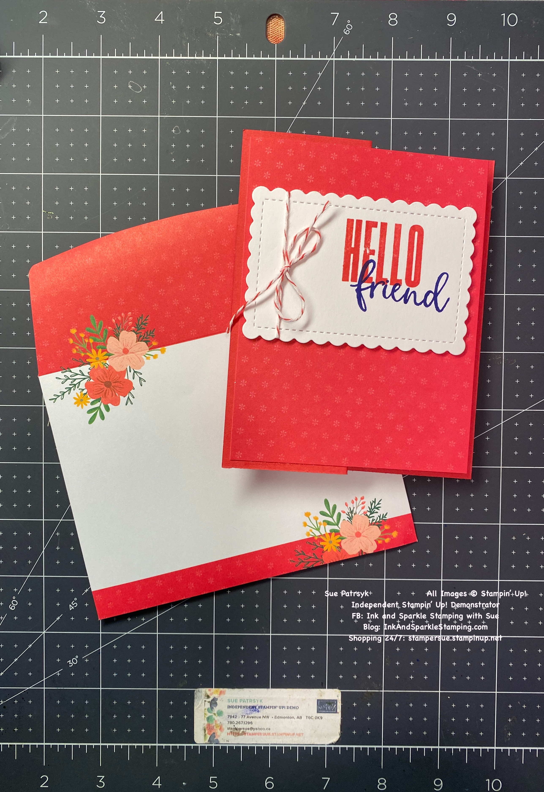All images © 2022 Stampin’ Up!® | Stamp Sets  - Biggest Wish Stamp Set (155052)  Ink, Markers, & Other Colouring Options  - Sweet Sorbet Ink Pad (159216)  - Orchid Oasis Ink Pad (159214)  Cardstock, Designer Series Paper, etc.  - Sweet Sorbet Cardstock (159268)  - Basic White Cardstock (159276)  - Tea Boutique Cards & Envelopes (159270)  Accessories  - Stampin’ Seal (152813) or Multipurpose Liquid Glue (110755); Stampin’ Dimensionals (104430)  - Scalloped Contour Dies (155560)  - 2022-2024 In Color Baker’s Twine Pack (159195)  - Optional: In-Color Matte Decorative Dots (159186)

Measurements:  - Sweet Sorbet Cardstock:  - Basic White Cardstock:  - Sweet Sorbet Baker’s Twine: | 8-1/2” x 5-1/2”, scored at 4-1/4” and 1-1/8” for the front flap  approx. 4” x 2-3/4”  12”

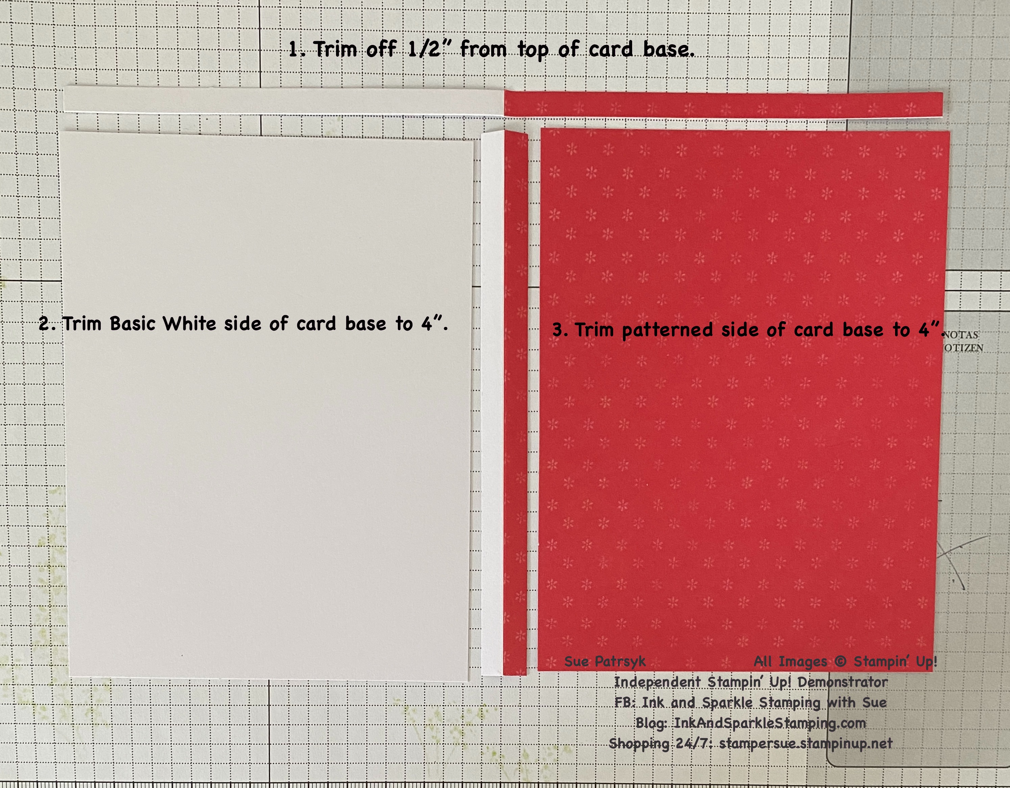
Instructions:
- Cutting Instructions for Tea Boutique card base: Lay card base flat in your trimmer and trim 1/4” from the long side. Turn the card base and cut the white back of the card down to 4” wide and then repeat with the patterned card front cutting it down to 4” wide (see picture).
- Adhere the 4” x 5-1/4” white panel to the inside of the Sweet Sorbet cardstock.
- Fold back the 2-1/8” score mark on the card front (it now has a “Z-fold shape to it). Add glue to the LEFT HALF of the back of the 4” x 5-1/4” patterned Tea Boutique card piece and adhere to the front of the 2-1/8” Sweet Sorbet card base flap.
- Die cut the scalloped rectangle with the die that is approx. 2-3/8” x 3-3/4” from the Basic White scrap.
- Tie the Sweet Sorbet Baker’s Twine in a knot near the left side of the Basic White scalloped rectangle then tie a bow as a second step with the twine.
- Stamp the greeting of your choice from the bold images in the stamp set. Position slightly to the right of center and high enough that you can stamp a coordinating word just below but slightly over top of the bold word. (see picture).
- Use Stampin’ Dimensionals to add the Basic White scalloped rectangle to the card front, slightly above center.
- Add your personalized greeting to the inside of the card. This time the coordinating envelope from the Tea Boutique Cards & Envelopes pack is already decorated for you. Address to someone special and enjoy giving your beautiful card away! You can always make more!!

Here is another couple of examples using the Tea Boutique Cards & Envelopes (no fancy card folds -- just using them as is!)

