Wildlife Wonder Card
FaceBook: Ink And Sparkle Stamping with Sue
Weds. May 25, 2022

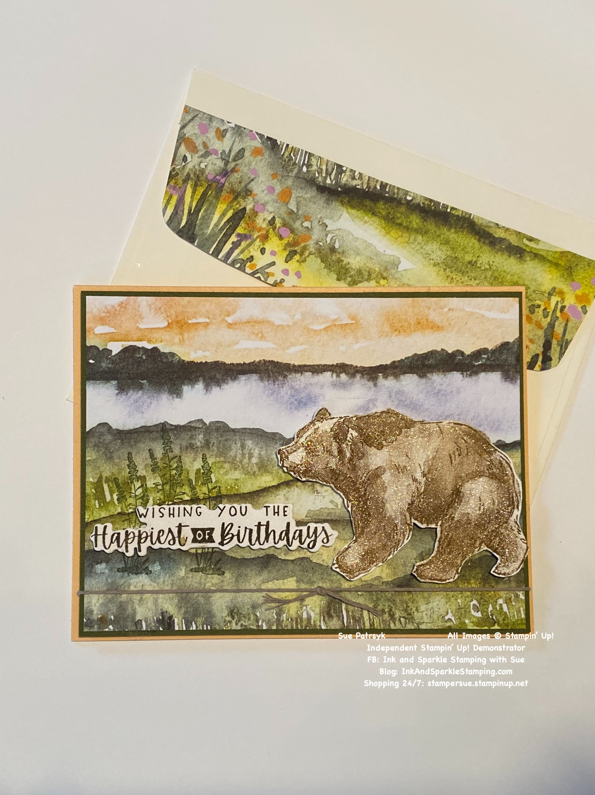All images © 2022 Stampin’ Up!® | Stamp Sets  - Wildlife Wonder Stamp Set (157923)  - Charming Sentiments Stamp Set & Die Bundle (158734)  Ink, Markers, & Other Colouring Options  - Soft Suede Ink Pad (147115)  - Early Espresso Ink Pad (147114)  - Mossy Meadow Ink Pad (147111)  - Wink of Stella Clear Glitter Brush (141897)  Cardstock, Designer Series Paper, etc.  - Pale Papaya Cardstock (155668)  - Mossy Meadow Cardstock (133676)  - Very Vanilla Cardstock (101650)  - New Horizons 6” x 6” Designer Series Paper (157768)  Accessories  - Stampin’ Seal (152813); Stampin’ Dimensionals (104430); Mini Stampin’ Dimensionals (144108)  - Baker’s Twine Essentials Pack (155475)

Measurements:  - Pale Papaya Cardstock:  - Mossy Meadow Cardstock:  - New Horizons DSP:  - Crumb Cake Baker’s Twine: | 8-1/2” x 5-1/2”, scored at 4-1/4 along the long side  5-3/8” x 4-1/8”  5-1/4” x 4”  13”

Instructions:
- Trim one pattern of the 6” x 6” New Horizons 6” x 6” piece of DSP (see photo for pattern).
- Use Early Espresso ink to stamp “Wishing you the Happiest of Birthdays” greeting onto a scrap of Very Vanilla cardstock. Cut out using the corresponding die.
- Use Soft Suede ink to stamp the bear image onto the 3-1/2” x 2-1/2” piece of Very Vanilla cardstock and use Paper Snips to cut out image, cutting just outside the line image.
- Add the DSP layer to the Mossy Meadow layer using Stampin’ Seal.
- Tie the Crumb Cake Baker’s Twine approx. 1/2” from the bottom edge of the DSP/Mossy Meadow layers and tie a square knot in the twine.
- Using Mossy Meadow ink, stamp the flower image 3 times near the left edge of the DSP at approx. 3/4” from the bottom edge being sure to leave enough space for the bear image on the right.
- Add Mini Dimensionals to the back side of the bear’s paws and nose and add full size dimensionals to the upper body. Add to the DSP layer (see picture for placement).
- Add Mini Dimensionals to the back of the greeting and add to the left of the bear, positioning so that the greeting is near the bottom of the flower images stamped in Moss Meadow.
- Add Wink of Stella Clear Glitter to the bear image.
- Stamp the wolf image and inside greeting on the inside of the card.
- Stamp the front and/or flap of the envelope if desired.
- Add your personalized greeting and enjoy giving/sending your beautiful card to someone special.

NOTE the 3-2-1 Stamp Products used this week:
3 x ink colours
2 x stamp sets
1 x ribbon/trim

